[This Photo](https://www.flickr.com/photos/isf-florence/14358833896/) by Unknown Author is licensed under [CC BY-ND](https://creativecommons.org/licenses/by-nd/3.0/)

Get ready to have a blast 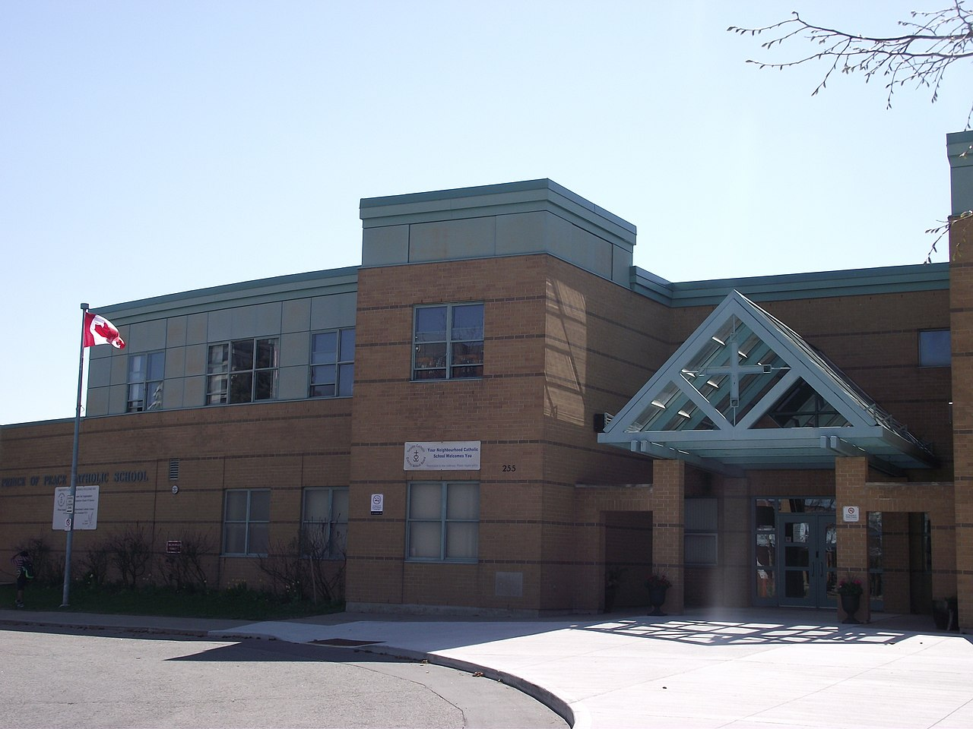

-------------------------------------

SPRING FIELD DAY

EVERYONE’S AN ATHLETE

-------------------------------------

04/28/23

12 NOON

SCHOOL FIELD/GYMNASIUM

123 GLENN ST UNION, NJ 07523